Appendix: Title [Heading 2: 16-point Calibri]

Please include all supplemental materials here. A separate appendix should be used for each distinct topic or set of data and always have a descriptive title. If you have more than one appendix, label these alphabetically (e.g., Appendix A, Appendix B, etc., followed by the title).
The formatting of the appendix should be the same as the formatting of the main text. The font should be 11-point Calibri and the text should be fully justified. The opening paragraph has no indentation. The second and subsequent paragraphs are indented by .25 inches.

Table 1. The table caption (11-point Calibri) should be center aligned and italicized (note: only the table number is bold). If you have more than one table, please use the same format for each table.
Variable | Domestic sources | Foreign sources | Conservative sources | Liberal sources | General sources
Presumed influence on oneself | 0.84 | 0.84 | 0.85 | 0.85 | 0.85
Presumed influence on voters | 0.84 | 0.86 | 0.90 | 0.86 | 0.83
Note: Provide additional context below the table as demonstrated here (9-point Calibri, center aligned, and italicized).

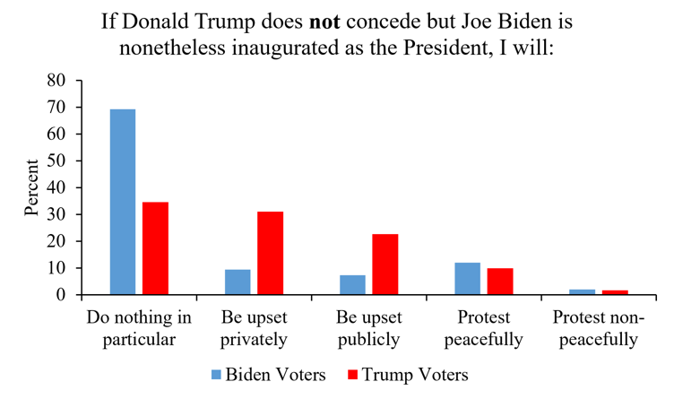
Figure 1. The figure number and caption (9-point Calibri) should be center aligned, bold, and italicized. If you would like to provide additional context, please use regular italics.

Please note that you will be asked to copy your appendix into this template once your manuscript is in production. This document will be uploaded to our website (under the web version of the article). If you have more than one appendix, please be prepared to send a separate file for each appendix.

